**Self-Evaluation**

**Conceptual Coverage:**



For conceptual coverage, I believe my project deserves 15 points as I have displayed at least one example of most of the concepts mentioned in the project task sheet. For instance, I have combined functions and visual applications through ASCII are. My final program also contains a series of loops, vectors, conditional execution, user input and output. However, the use of functions is limited to only one, and my code does not contain Matrices, therefore I have given myself 15/20. There are a number of if loops, for loops and while loops used in my program these loops are key for the success and application of the game, the loops are layered within each other and work in harmony in order for the program to run.

**Value Add:**



For Value add I believe my code deserves 15 points, as there are several aspects which I have added to it, which make it user friendly. For instance, the user is told what attempt number they are on rather than just forcing them to remember. The code also provides the user with a choice, of playing easy mode or hard mode. The code also explains the rules and guides the user, for example when the user does not enter a 3 or 6 letter word the program will prompt them to do so.



For functionality, curly brackets were utilized for arrays rather than square brackets containing the random words the computer would choose from, as these cell arrays are able to store character data in their elements.

**Incremental Development:**



For incremental Development, I believe my project deserves 20 points, as I have demonstrated substantial evidence of progress throughout multiple files within the project. My project contains 5 different developmental stages with small or big changes occurring in each of them. Each of these stages contain separate files with smaller bits of code which is tested before being added to the main program. From the first to the second variation, the code is substantially changed as the addition of vectors occurs. From the second to the third, a similar but easier version of the same game is developed, for a big change to occur in the fourth development stage. In the fourth development stage the option of multiple modes is added. The use of ASCII art is also an addition. In the fifth and final stage, the code is cleaned up and layered correctly.

**Testing:**

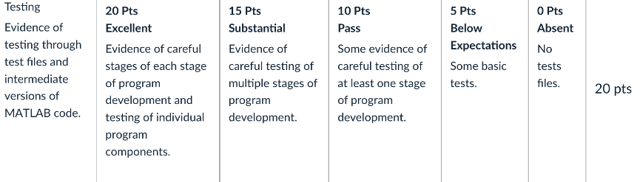



For testing I believe my code should receive full marks, as each small incremental part is tested separately, before being added to the main code. Once it is added to the main code, the main code is also tested for functionality. This process is repeated throughout the development of the project.

**Comments and Styling**



The final version of my game is layered, clean, and has high quality aesthetics. Additionally thorough and explaining what each component of the code accomplishes is the commentary. Similar to this, the application, use, and goal of the code are explained in the comments present throughout each project file. Additionally, the styling is done to a respectable standard throughout all incarnations of Guess that word. Smaller test codes' styling, however, is not as nice.